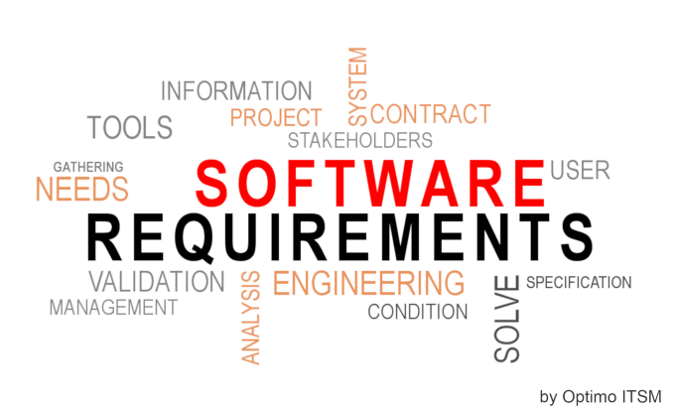
A software requirement specification is a Comprehensive description of the intended purpose and environment for software under development. The SRS fully describes what the software will do and how it will be expected to perform.

A software requirement specification(SRS) is a Comprehensive description of the intended purpose and environment for software under development. The SRS fully describes what the software will do and how it will be expected to perf

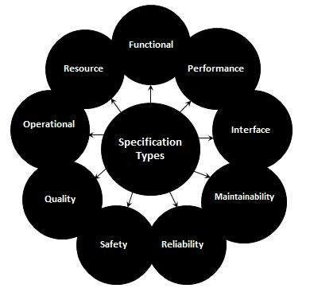
Software requirement specification of Mini Mart
Prepared by
Sushmitha Gonnabathula
30-6-2022
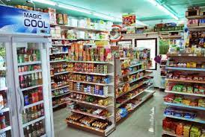

Contents
Introduction
Purpose
Scope of project
Glossery
References
Overview of document
Overall description
Functional requirement specification
Brief description
User characteristics
Features of google slides
Easy to design slides
Unlimited revision history
Simple sharing control
Non functional requirements
External interface requirements
Functional requirements
Article
Detailed non functional requirements
Security

List of Figures

Figure 1 - System Environment 4
Figure 2 - Article Submission Process 6
Figure 3 - Editor Use Cases 8
Figure 4 - Logical Structure of the Article Manager Data 23

Introduction

Web application system has been commonly used to replace the manual operation in an organization. The rapid growth of computer use and the internet, both in business and in the home, offers another way that purchases can be made: consumers can make purchases online. Customers can quickly search on the internet for products according to their wanted specifications and then they can complete the purchase online using virtual shopping carts that can record the choices that a customer makes.

After proceed with payment, the products will be delivered to the customer’s location that was provided earlier on. In this environment of customer choice, students have the ability to search for a range of products on the web application often with better choice and expedience compared with traditional retail shopping. Similar idea was proposed due to help student to manage time and effort better and to help the university mini mart to be more uniform and productive.

Student who often uses the university mini mart services frequently face problem where sometime item that student is looking for to buy is not in stock, for example milk and bread. Thus, this project was proposed that is to have a web-based application platform to cater the student and the university mini mart operator. This system will be easier for the student as it will display what the university mini mart is selling and the availability in stock

This web based application system namely I-Mart developed in coherent with Software Development Life Cycle (SDLC) that is Waterfall-model. Programming approach was differentiated to apply the APRIORI model in order to develop the buying pattern module. Several phases were designed that are requirement gathering phase where student performed data collection via literature review and analyzing environment of mini mart, design and development of the system, testing to demonstrate simulation by testing sample of inventory records using black-box testing and white-box testing methods, and last phase that is reporting. All phase were done within period of two semesters and all input and output of this 2 project were documented within this report.

Purpose

Mini-mart means a convenience store which sells snacks, groceries, personal items, and personal services typically associated with the sale of gasoline and/or sale of alcoholic beverages and open fourteen to twenty-four hours a day.

1.2. Scope of Project
I-Mart is a web based application system involves both the user side and administration side. There is also Main Page, where the user needs to login before put their order in the checkout/order page. The details are as follows: Figure 1.1: User Role in I-Mart In order to test for the functionality of each module, sample of inventory from mini mart were recorded within the system. These data further being used to recognize the buying 6 pattern of customer.
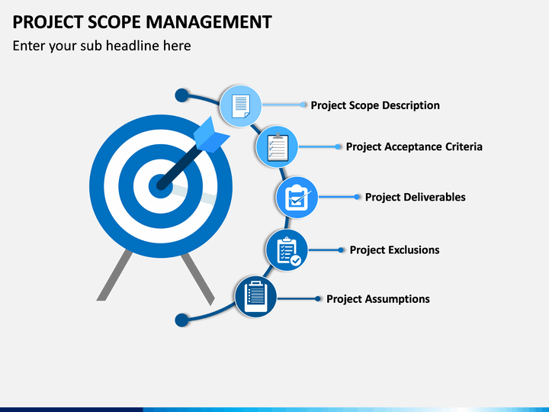

1.3. Glossary
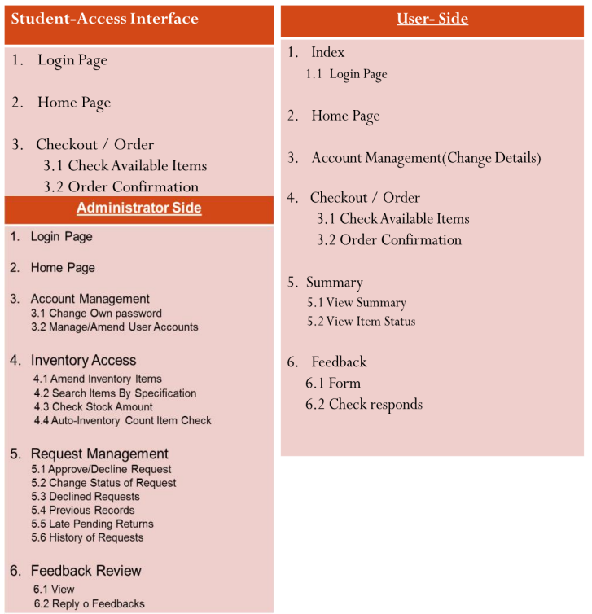

Limitation of Project

1.5.1 Time Constrain Development of I-Mart is bound to time allocated for FYP 1 and FYP 2 which cover period of two semester. Real project development for inventory management system will require longer time for each phase. To solve this issue, student minimizes the scope for the whole project to be finished within time frame estimated. 1.5.2 Simulation Based on Sample of Inventory This project developed based on simulation for inventory management of mini mart in college residency. However the if student are to apply full scale simulation which include all inventory within a mini mart, these will require longer time, bigger and different system design. Therefore, this project will only include a sample of inventory for the system simulation.
References
Minit Mart LLC is a chain of convenience stores operating in South central and Western Kentucky, Northern middle Tennessee, Eastern Wisconsin, Kansas City, Northeast Illinois, and Northeast Ohio. Its corporate offices are located in Cincinnati, OH, and the chain consists of 231 locations scattered around the United States

1.5. Overview of Document
Mini-mart means a retail establishment which contains less than 10,000 square feet of gross floor area utilized in whole or in part for the sale of a variety of items including groceries, delicatessen items, staples, dairy products, pre-packaged food, soft drinks, sundry items, and/or alcoholic beverages, and may include the sale of gasoline or other petroleum products. “Mini-mart” is distinguished from a “convenience market” in that it does not devote at least ten percent of its overall floor area to the display and sale of fresh meat and produce. Any mini-mart that sells alcoholic beverages shall be deemed a primary alcoholic beverage establishment.

2.0. Overall Description

2.2 Functional Requirements Specification
This is a functional specification requirements presentation Mini Mart. This is a three stage process. The stages in this process are business requirements, user requirements, system requirements. Jump over obstacles with our Functional Specification Requirements Presentation Mini Mart. Make sure your presentation gets the attention it deserves.
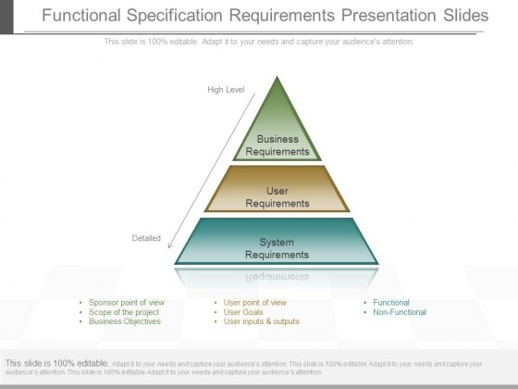

Brief Description

Mini-mart means a retail establishment which contains less than 10,000 square feet of gross floor area utilized in whole or in part for the sale of a variety of items including groceries, delicatessen items, staples, dairy products, pre-packaged food, soft drinks, sundry items, and/or alcoholic beverages, and may include the sale of gasoline or other petroleum products. “Mini-mart” is distinguished from a “convenience market” in that it does not devote at least ten percent of its overall floor area to the display and sale of fresh meat and produce. Any mini-mart that sells alcoholic beverages shall be deemed a primary alcoholic beverage establishment.

Initial Step-By-Step Description
1. Decide whether you want to start your store from the ground up or buy into a franchise. A lot of money will be required in either case, but franchising may occurs
2. Develop your business and marketing plans, regardless of whether you are opening your own convenience store or a franchise. Though it may be slightly ...

3. Determine a budget for startup costs. This will largely depend on the cost of real estate in
Mini mart

User Characteristics

Mini markets are fantastic additions to companies of any size. Larger organizations can use mini markets to complement their cafeterias, micro markets, or attended markets. If these options are out of budget or impractical for smaller offices, mini markets offer a great alternative.
A mini market is also convenient and compact enough to fit in almost any room or area. So, where should you put your mini market? Here are three characteristics of spaces that would be perfect for your new mini market.

Features of Mini Mart
Minimart is a menu builder, order management, and customer communication tool. Our goal is to drastically simplify the admin side of your business so you can focus on delivering great products and service. Each shop comes with a structure that helps you get started, but is customizable to fit your unique business needs.

With Minimart you can...

Manage Your Menu

Set Inventory Limits

Receive Orders

Track Payments

Fulfill Orders

Publish a Mini Website

Receive Expert Support

1. Manage Your Menu

Minimart shops come with a menu template that's easy to edit and flexible enough to sell a wide variety of offerings, from weekly pre-orders to one-off ticketed events. You can create organized sections with detailed item descriptions, and make quick edits throughout your week.

2. Set Inventory Limits

Don't let underselling or overselling take over! We know anticipating production capacity is key to growing your business. When you promise goods to a customer, you want to be sure you can make them. Take control of your sales output and optimize your prep time by setting specific limits on items.

3. Receive Orders

Minimart’s elegant and simple ordering system means you can be proud to link customers to your shop, knowing it will be easy to read and place an order. And instead of receiving orders in a million places like DMs, emails, or Google forms, all your orders live in one place. This means you can see a summary of all the prep you need to do in advance and optimize your kitchen work.

4. Track Payments

Allow your guests to pay with several major cash-like payments to avoid credit card fees. We support Venmo, PayPal, Zelle, Apple Pay, and CashApp, and we also offer credit card processing for those who use Square. We also know accounting with Venmo payments can be a real pain when you're trying to track down who paid for what. To make things less annoying, Venmo payments on Minimart automatically include the invoice number and total cost.

5. Fulfill Orders

Organize your orders, print tickets, and alert customers when their orders are ready or have been dropped off.

6. Publish a Mini Website

Minimart isn't just a shopping cart or e-commerce platform. Our service comes with a customizable set of pages that allow you create an online destination for your guests. You can set the tone with images, a mission statement, or provide terms and info on your landing page to eliminate the tedious task of customer communication. Plus, the pages and your shopping cart are managed conveniently in the same place.

7. Receive Expert Support

Minimart's founder began as a cook in independent restaurants over ten years ago, and has since worked in the industry helping solve problems with technology and create lasting brands. Minimart was built on tremendous experience, a deep sense of care for those in the industry, and the goal of providing high quality software at an affordable price to food entrepreneurs.

Simple sharing controls
Every retail outlet is a lifeline for the people from the close-knit community in the surrounding areas in a small town. Grocery stores don’t come by a dime a dozen in remote regions, and the people welcome it with open arms. Not only do such stores give a boost to the economy but also shape it to embrace progressive change and development of existing infrastructure.
Every business plan starts with small steps and leads to bigger things in the course of time. Whether it’s a grocery store in a village or a Kirana store in the city, the roadmap to setting up is always the same. The only thing that differs is the people and their mindset towards such a store. Let’s look at the initial steps for a grocery store business plan in a village.

2.4 Non-Functional Requirements
The non-functional requirement says about “what a system should be” rather than “what a system should do” (functional requirement). They are mostly derived from functional requirements based on input from the customer and other stakeholders. Non-functional requirement implementation details are documented in the System Architecture document.
Non-functional requirements explain the quality aspects of the system to be constructed viz. performance, portability, usability, etc. Non-functional requirements, unlike functional requirements, are implemented incrementally in any system.

3.0. Requirements Specification

3.1 External Interface Requirements
According to Richard Thayer (2002), "External interface requirements specify hardware, software, or database elements with which a system or component must interface...." This section provides information to ensure that the system will communicate properly with external components.

3.2.1 Search Article
Use Case Name | Mini mart
XRef | Section 2.2.1, Search Article  SDD, Section 7.1
Trigger | Triggers let Apps Script run a function automatically when a certain event, like opening a document, occurs.
Precondition | The Web is displayed with grids for searching
Basic Path | - Plan ahead and set a goal  - · 2. Take the necessary licenses and certifications ·  - 3. Streamline a Budget Plan ·  - 4. Go digital for the grocery
Alternative Paths | a retail store that carries a limited selection of basic items, as packaged foods and drugstore items, and is open long hours for the convenience of shoppers.
Postcondition | Cells, rows, or columns can be formatted to change text or background color if they meet certain conditions. For example, if they contain a certain word or a number.
Exception Paths | Collaborative, smart, secure spreadsheets for fast-moving organizations
Other

3.3 Detailed Non-Functional Requirements

3.3.1 Logical Structure of the Data

a layout design or store design, a retail store layout is a term used to describe how retailers set up their merchandise, product displays and fixtures in a store.

Security



10 Security Measures Common in Today's Mini Stores
- Video surveillance systems that capture recorded footage and provide real-time monitoring.
- Prominent signs that inform customers the store is under surveillance and/or protected by an electronic security system.
- Unblocked windows and doors to maximize site lines.
LIST OF FIGURES
System Environment
supermarket, large retail store operated on a self-service basis, selling groceries, fresh produce, meat, bakery and dairy products, and sometimes an assortment of nonfood goods.

Article Submission process
Independent grocery stores earn a margin of 1-4% while the bigger brands earn more than 5%. While keeping the costs in check, opening a grocery store is among the profitable businesses in India.
Editor use cases
A Mini Mart store, convenience shop, corner store or corner shop is a small retail business that stocks a range of everyday items such as coffee, groceries, snack foods, confectionery, soft drinks, ice creams, tobacco products, lottery tickets, over-the-counter drugs, toiletries, newspapers and magazines.

Index

Abstract, 6, 17, 27
add, 9, 11, 19, 20, 21
Add, 8, 9, 19
Article, 1, 5, 6, 7, 8, 9, 10, 11, 12, 13, 14, 15, 16, 17, 18, 19, 20, 21, 22, 23, 24, 25, 26, 27, 28
Article Manager, 5, 8, 9, 10, 11, 12, 13, 14, 15, 16, 19, 20, 21, 22, 23, 24, 25, 28
Author, 1, 4, 5, 6, 7, 8, 9, 13, 14, 16, 17, 19, 20, 22, 23, 25, 26, 27
Category, 5, 14, 17, 18, 20, 21, 23, 26, 27
Database, 2, 9, 11, 14, 15, 16, 17, 18, 19, 20, 21, 22, 24, 25, 26, 27
Editor, 1, 4, 5, 6, 7, 8, 9, 10, 11, 12, 13, 14, 15, 16, 17, 19, 20, 21, 22, 23, 24, 25, 28
Field, 17, 19, 20
Form, 1, 6, 9, 10, 11, 12, 14, 19, 20, 21, 23, 24, 27
Grid, 9, 11, 12, 19, 20, 21
Historical Society, 1, 5, 9, 11, 16, 17, 19, 20, 26
Online Journal, 4, 5, 6, 7, 15, 16, 17, 18, 24, 27, 28
Reader, 4, 5, 6, 16, 17, 18
Review, 1, 7, 11, 12, 18, 21, 23, 26, 27
Reviewer, 1, 4, 5, 6, 7, 9, 11, 16, 17, 19, 20, 21, 22, 23, 26, 27
Security, 27, 28
Status, 11, 12, 13, 14, 17, 21, 22, 23, 27
update, 9, 11, 20, 21
Update, 8, 9, 10, 11, 12, 13, 14, 15, 17, 19, 20, 21, 22
User, 7, 16, 18
Web Publishing System, 1, 4, 5, 17

